Assignment no.1

OOP assignment console-based Messaging App

|  |  |
| --- | --- |
| **Submitted by:** | **M.Reyan** |
| **Roll no.** | **SP24-BSE-080** |
| **Submitted to:** | **Dr Shahid Bhatti** |

**Welcome to my Messaging App**

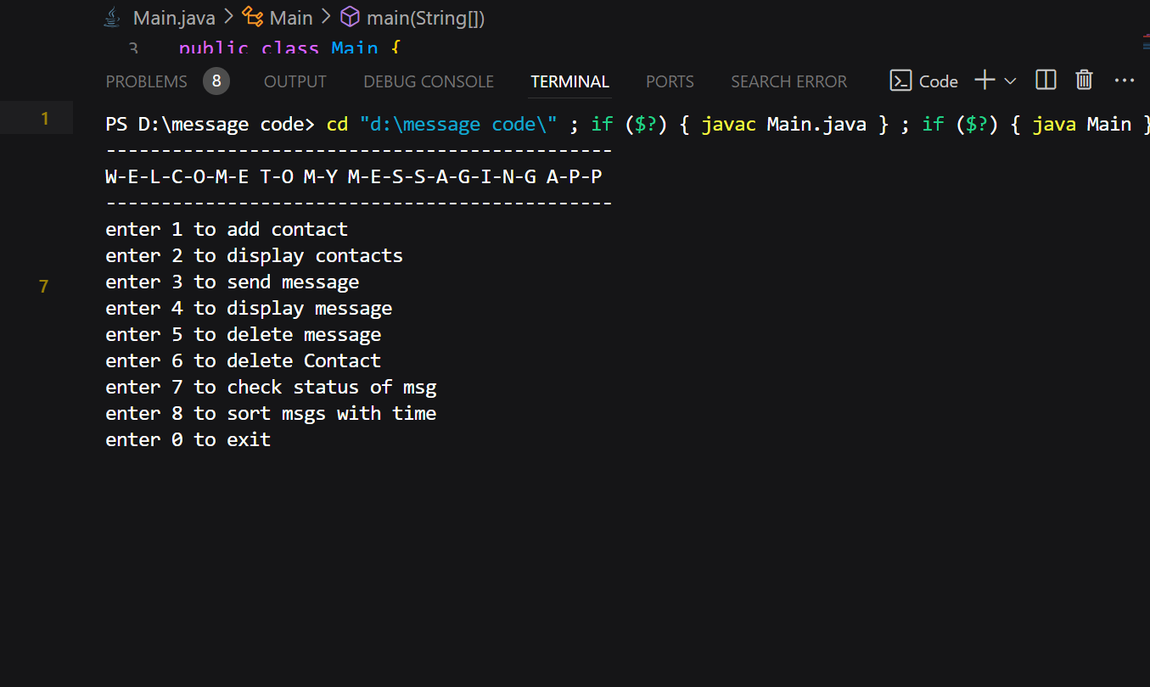

* **This is the menu of my messaging app that shows on the console when we run the main file.**
* **My messaging app contains many functions which I’ll show line wise how it works.**

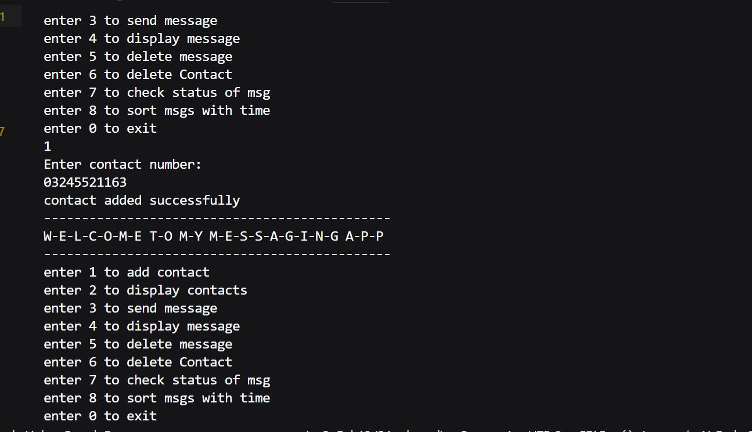

* **If we press 1, we can add contact number after adding a suitable contact number contact will add to our app successfully.**
* **I only added 1 contact number.**
* **After adding contact, the menu will show again to ask what you want to do now.**

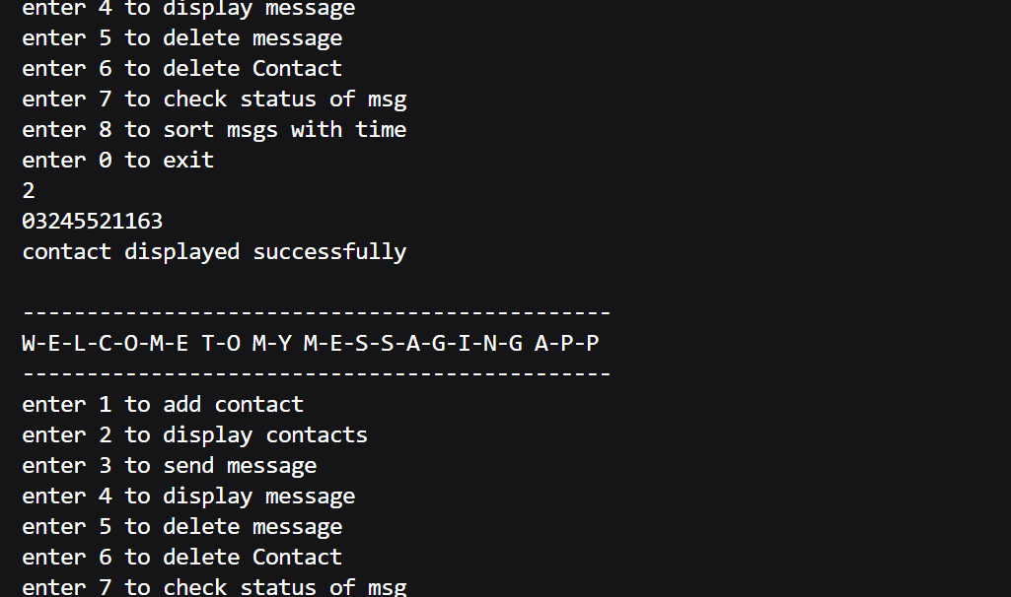

* **The second function was to display contact numbers.**
* **If we press 2, the contact number will display.**

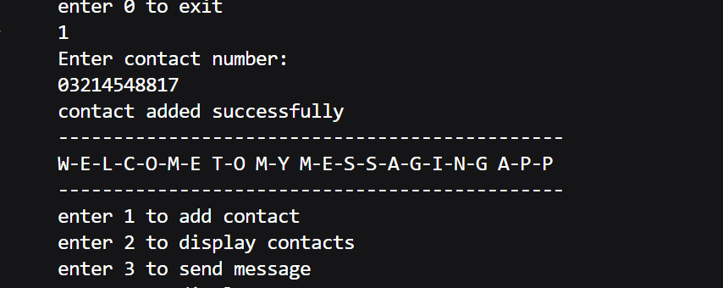

* **If I add a new contact number.**
* **And we have function to delete contact so by pressing 6 we can delete contact .**

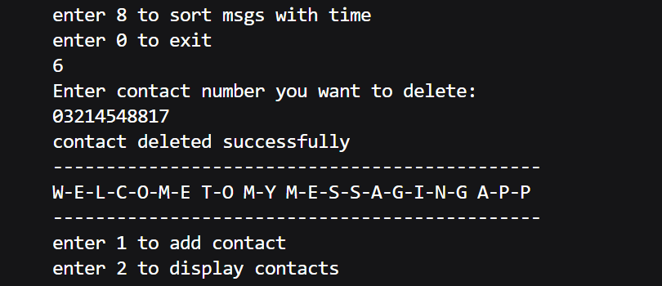

**As I deleted one contact so I can check whether contact is deleted or not by displaying contact.**

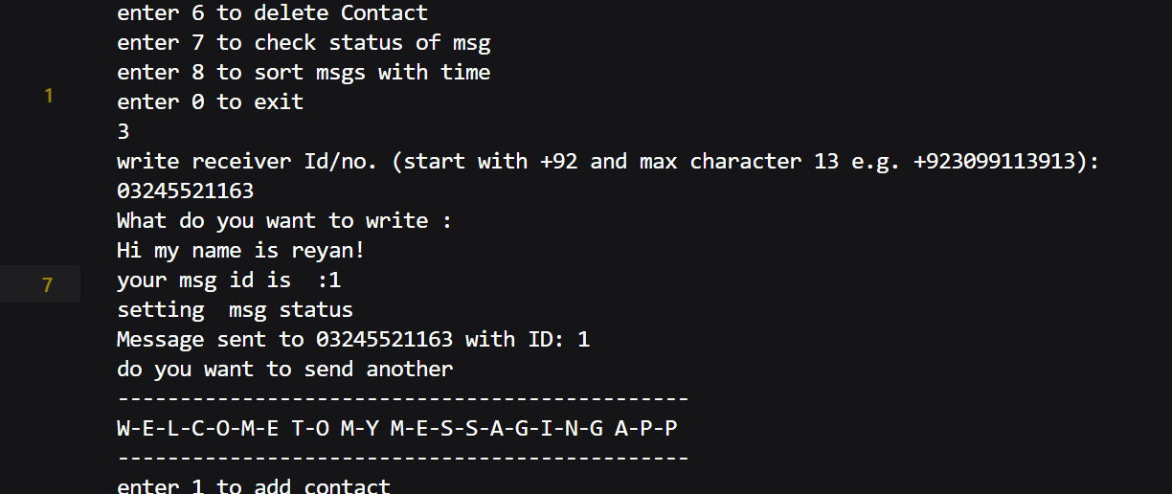

* **If we press 3, we can send msg to our contact and the msg will be assigned to an ID .**
* **And we can send another msg.**
* **As you can See we have msg display function.**
* **If we press 4 the console will ask the contact number whose msg u want to display by entering the number, the program will display the msg of that contact with every info and that msg id.**

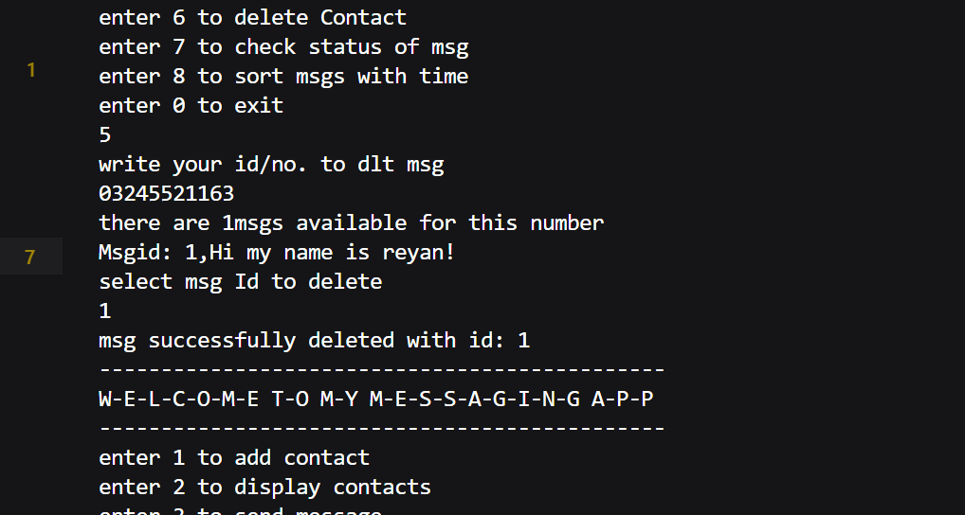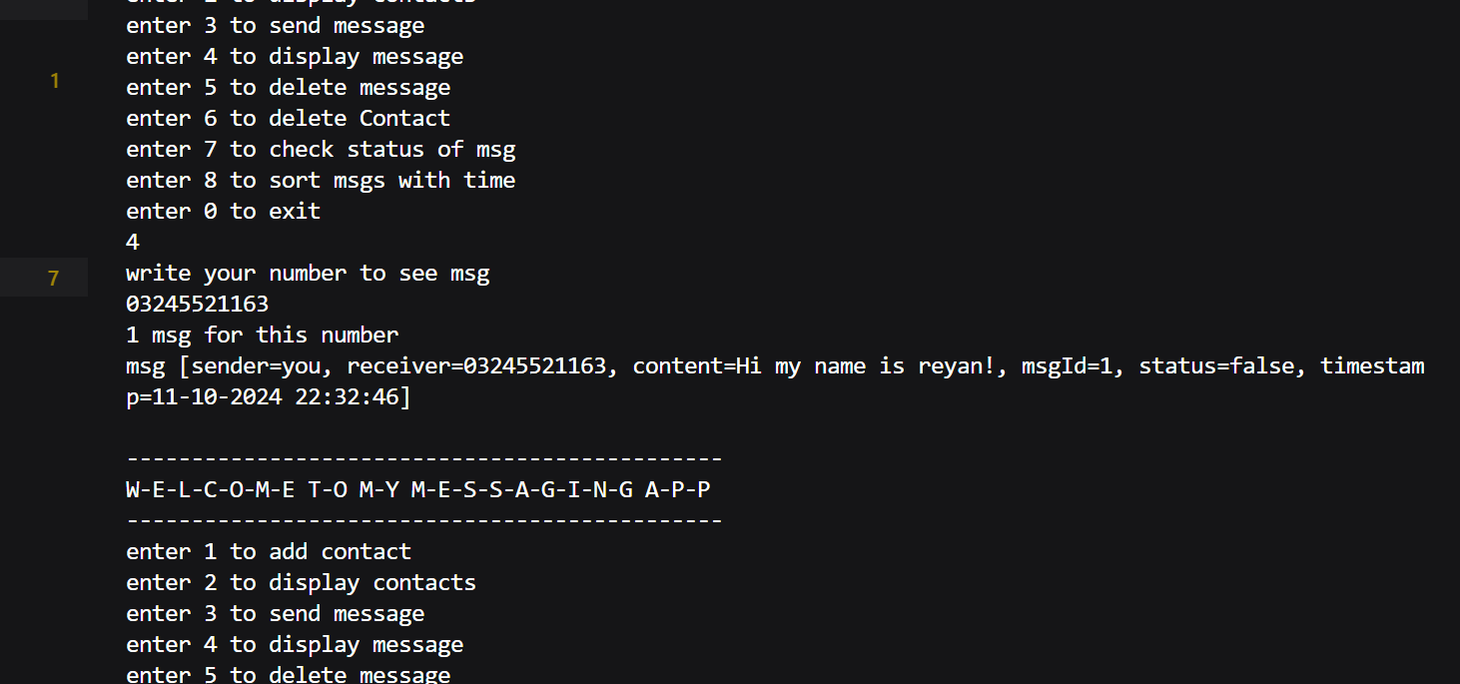

* **If we press 5, we can delete that msg for some contact for deleting the msg the screen will ask for the first contact number and that msg ID.**

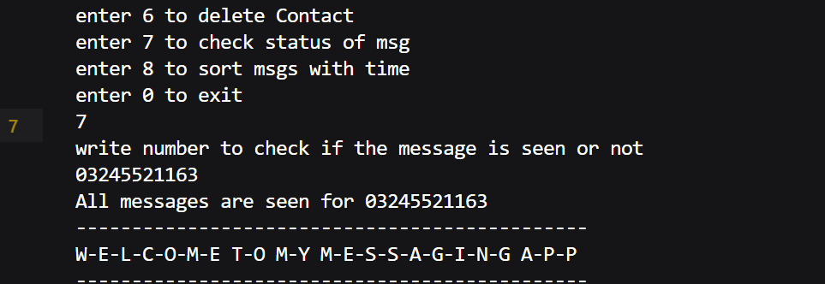

* **If we press 7, it will show the status of the msg that it is seen or not the console will ask number to display the msg status.**

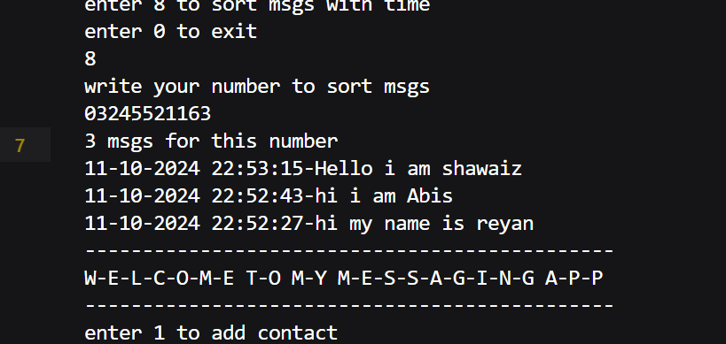

* **If we press 8, the msg will be sorted according to time for that contact.**

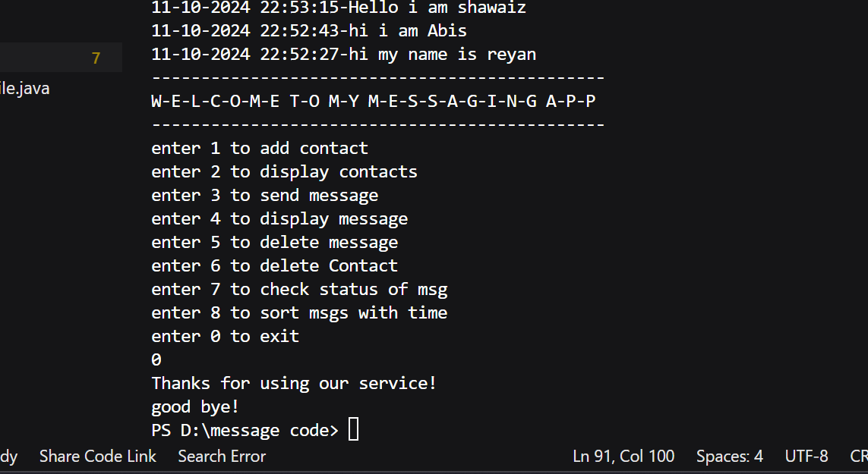

* **To exit the App press 0 and you will get out of the app.**

**Thank you for using our App**

**WE HOPE THAT YOU LIKED IT!**